**Create Table:**

CREATE TABLE table_name (  
    column1 datatype,  
    column2 datatype,  
    column3 datatype,  
   ....  
);

**Example:**

CREATE TABLE Persons (  
    PersonID int,  
    LastName varchar(255),  
    FirstName varchar(255),  
    Address varchar(255),  
    City varchar(255)  
);

**Insert:**

INSERT INTO table_name (column1, column2, column3, ...)  
VALUES (value1, value2, value3, ...);

***Example:***

INSERT INTO Customers (CustomerName, ContactName, Address, City, PostalCode, Country)  
VALUES ('Cardinal', 'Tom B. Erichsen', 'Skagen 21', 'Stavanger', '4006', 'Norway');

**Select:**

SELECT column1, column2, ...  
FROM table_name;

**Example:**

SELECT CustomerName, City, Country FROM Customers;

SELECT * FROM Customers;

***With “where” clause***

SELECT column1, column2, ...  
FROM table_name  
WHERE condition;

**Example:**

SELECT * FROM Customers  
WHERE CustomerID = 1;

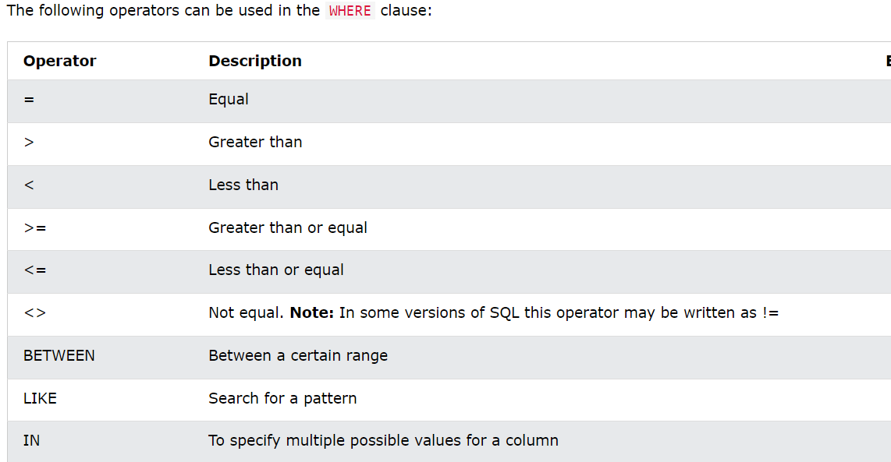

**Update:**

UPDATE table_name  
SET column1 = value1, column2 = value2, ...  
WHERE condition;

**Example:**

UPDATE Customers  
SET ContactName = 'Alfred Schmidt', City = 'Frankfurt'  
WHERE CustomerID = 1;

**Delete**

DELETE FROM table_name WHERE condition;

**Example:**

DELETE FROM Customers WHERE CustomerName='Alfreds Futterkiste';

Delete All Records:

DELETE FROM table_name;

**Limit:**

SELECT column_name(s)  
FROM table_nameWHERE condition  
LIMIT number;

**Example:**

SELECT * FROM Customers  
WHERE Country='Germany'  
LIMIT 3;

What if we want to select records 4 - 6 (inclusive)?

SELECT * FROM Customers  
LIMIT 3 OFFSET 3;

**Order By:**

SELECT column1, column2, ...  
FROM table_name  
ORDER BY column1, column2, ... ASC|DESC;

**Example1:**

SELECT * FROM Customers  
ORDER BY Country;

**Example2:**

SELECT * FROM Customers  
ORDER BY Country ASC, CustomerName DESC;